CS 255 System Design Document

This template lays out all the different sections that you need to complete for Project Two. Each section has guidance to prompt your thinking. You will need to continually reference the interview transcript as you work to make sure that you are addressing your client’s needs. There is no required length for the final document. Instead the goal is to complete each section based on what your client’s needs are. Remove this note when you are finished, and replace all bracketed text with the relevant information.

UML Diagrams

UML Use Case Diagram
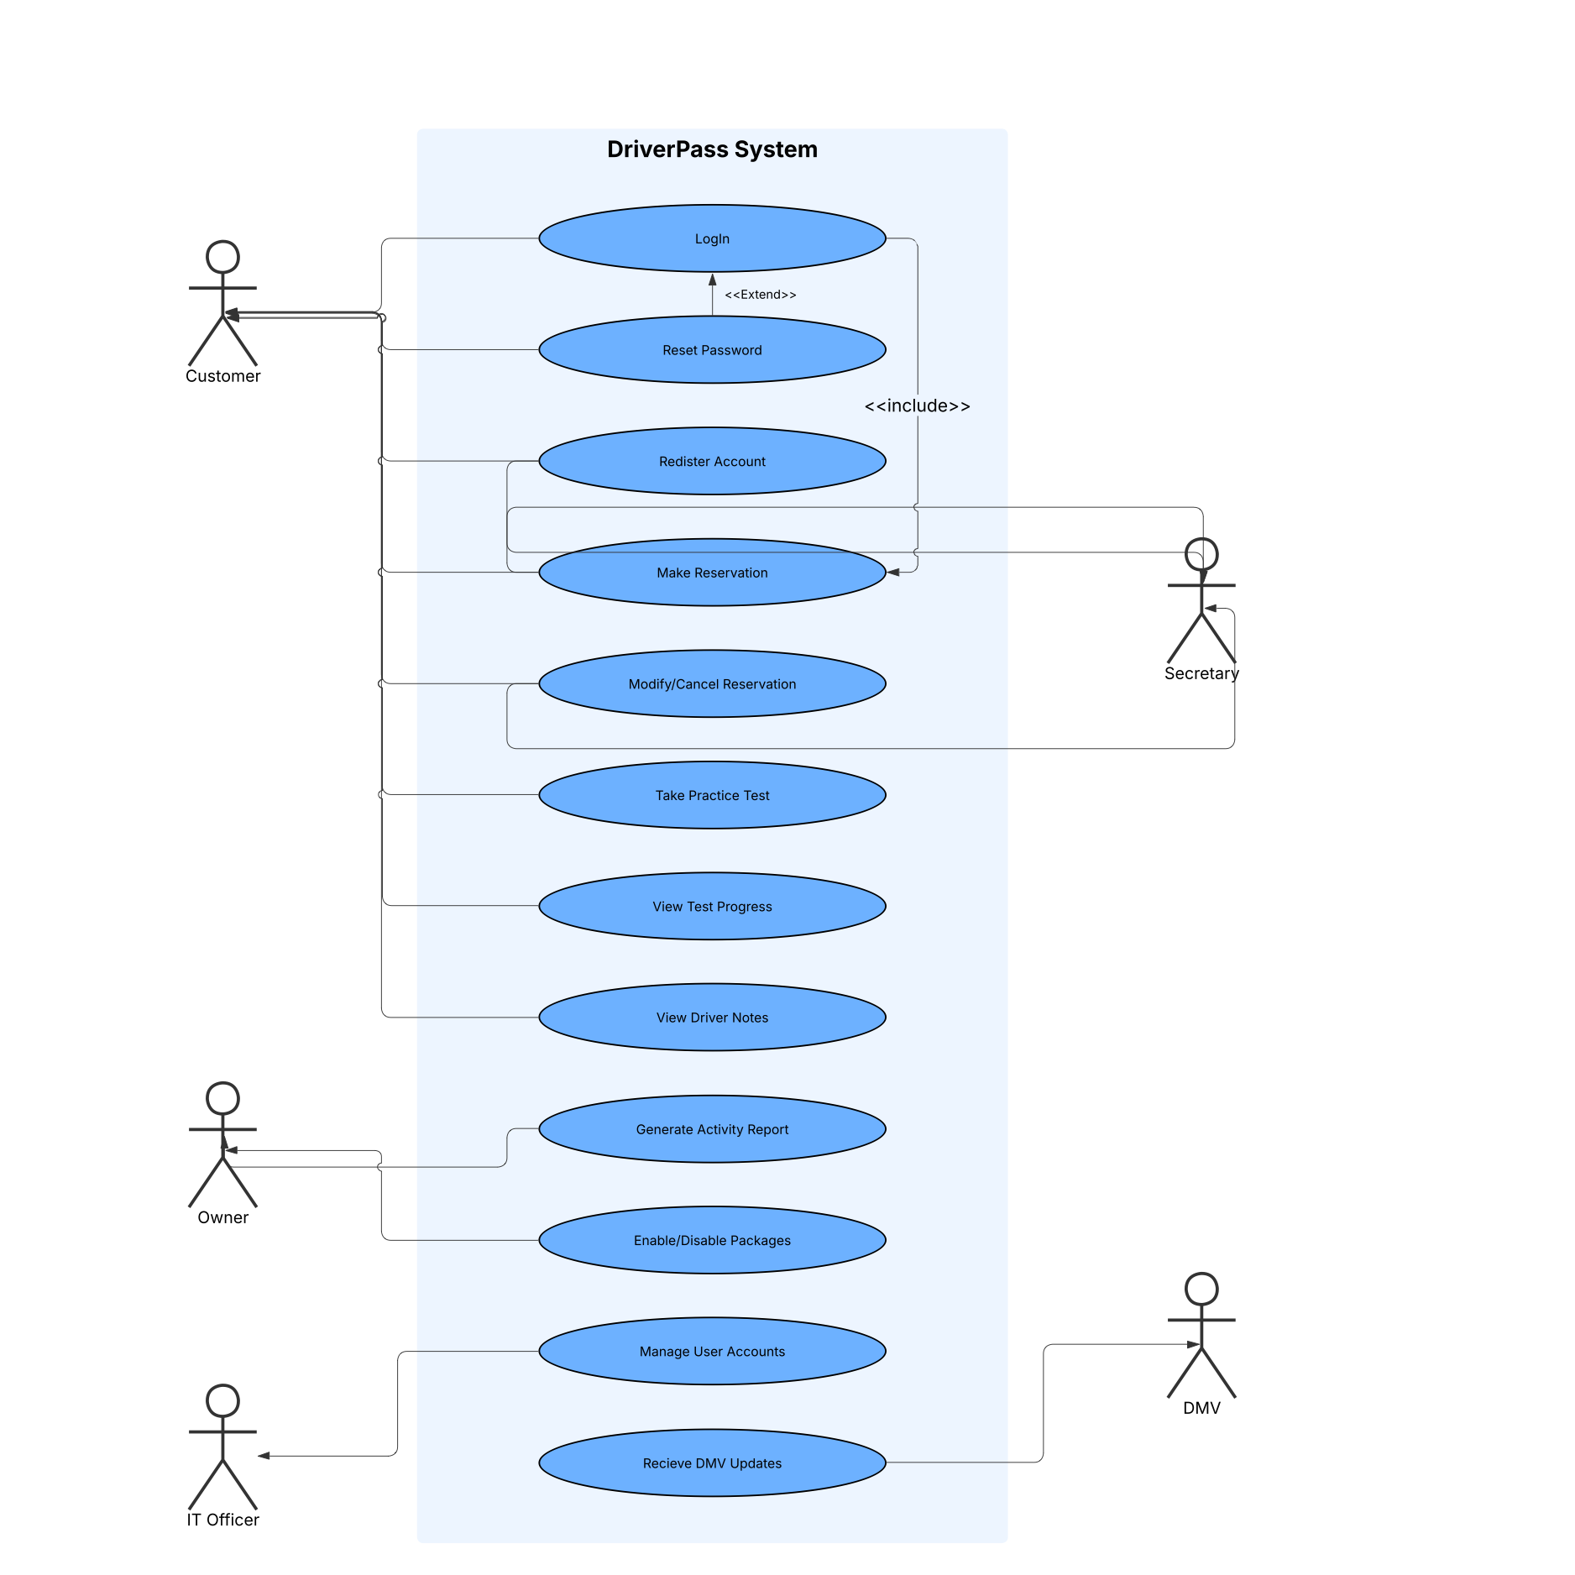
[In Module Six, you were asked to complete a use case diagram based on your system design. If you would like to make any adjustments to your diagram, please do so. Please insert your use case diagram here. Check to make sure that you included appropriate components and symbols and that your design meets the client’s needs.]

UML Activity Diagrams
[You were asked to choose two use cases and create two activity diagrams, one for each use case. Please insert both of your activity diagrams here. Check to make sure that you included appropriate components and symbols and that your design meets the client’s needs.]

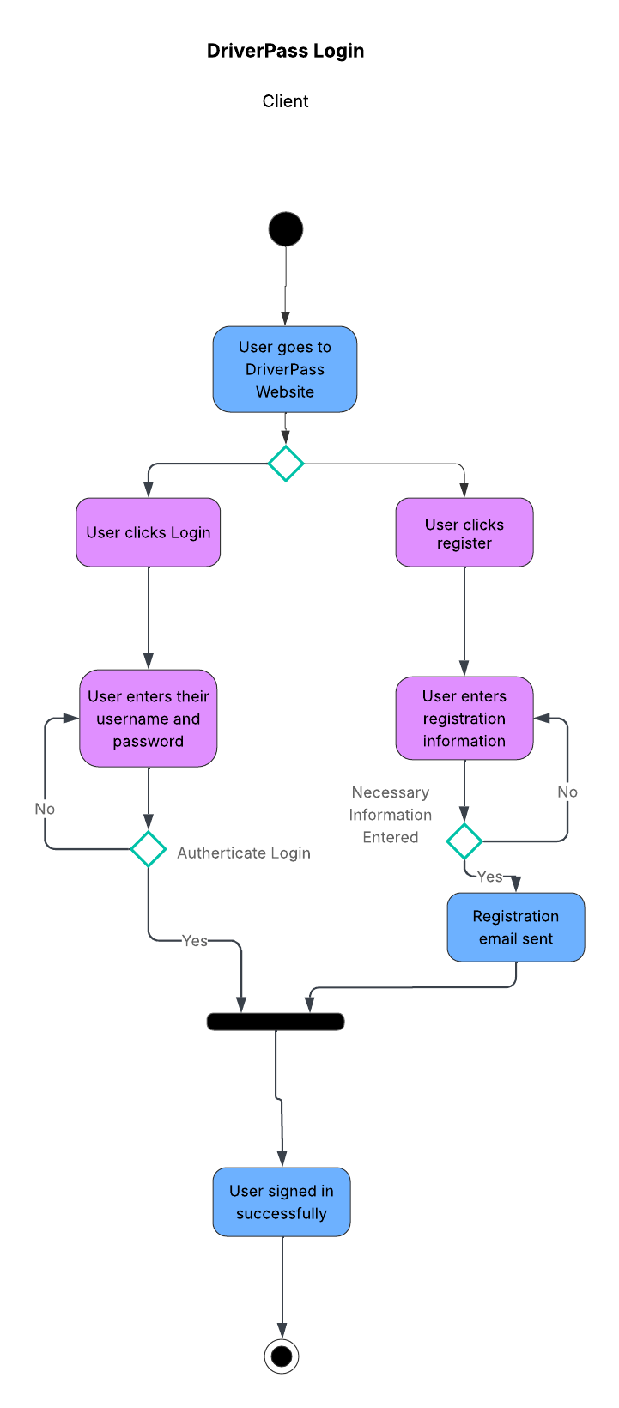

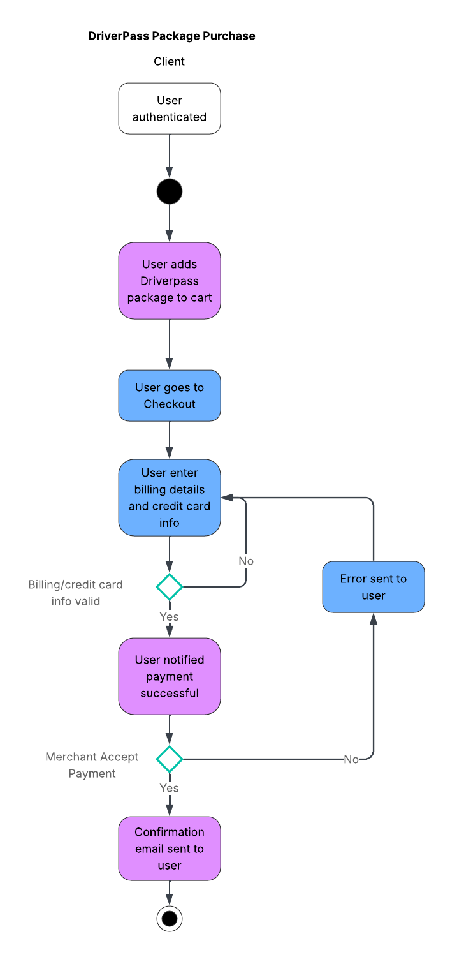

UML Sequence Diagram
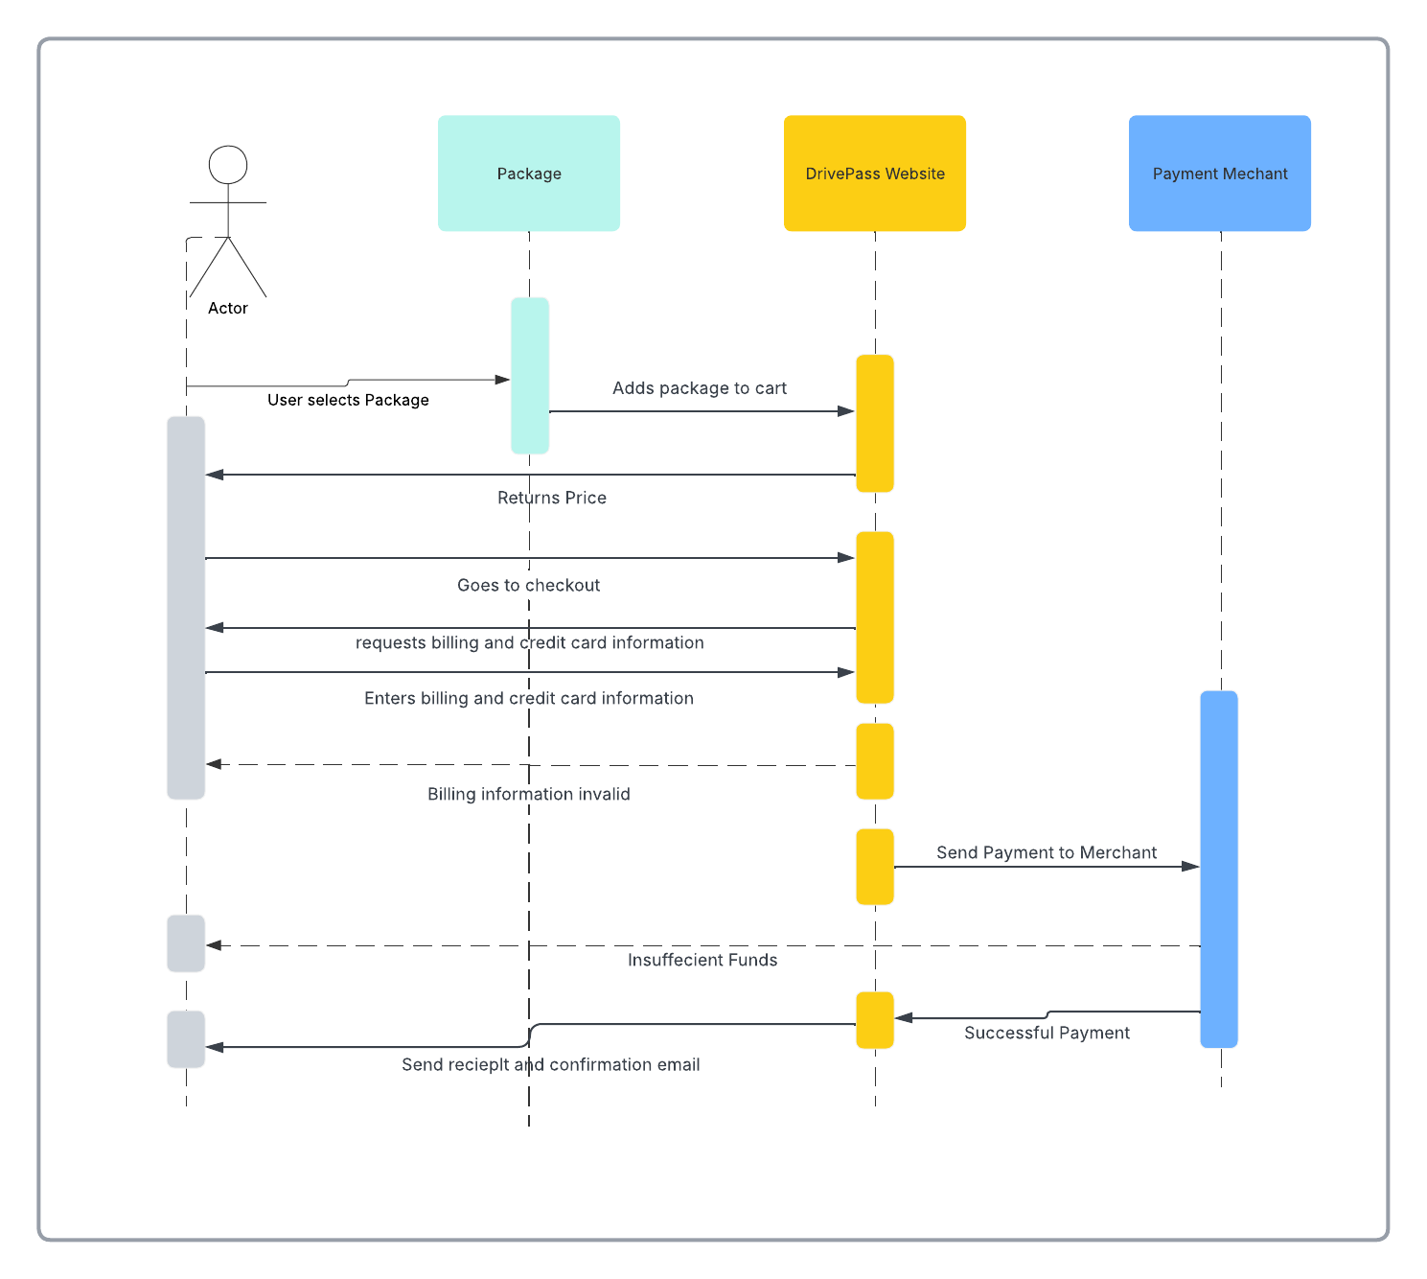
[You were asked to create a sequence diagram based on one of the use cases you chose. Please insert your sequence diagram here. Check to make sure that you included appropriate components and symbols and that your design meets the client’s needs.]

UML Class Diagram
[You were asked to create a class diagram based on the different classes and attributes needed for your system design. You are not required to include methods, but you may if you wish. Please insert your class diagram here. Check to make sure that you included appropriate components and symbols and that your design meets the client’s requirements.]
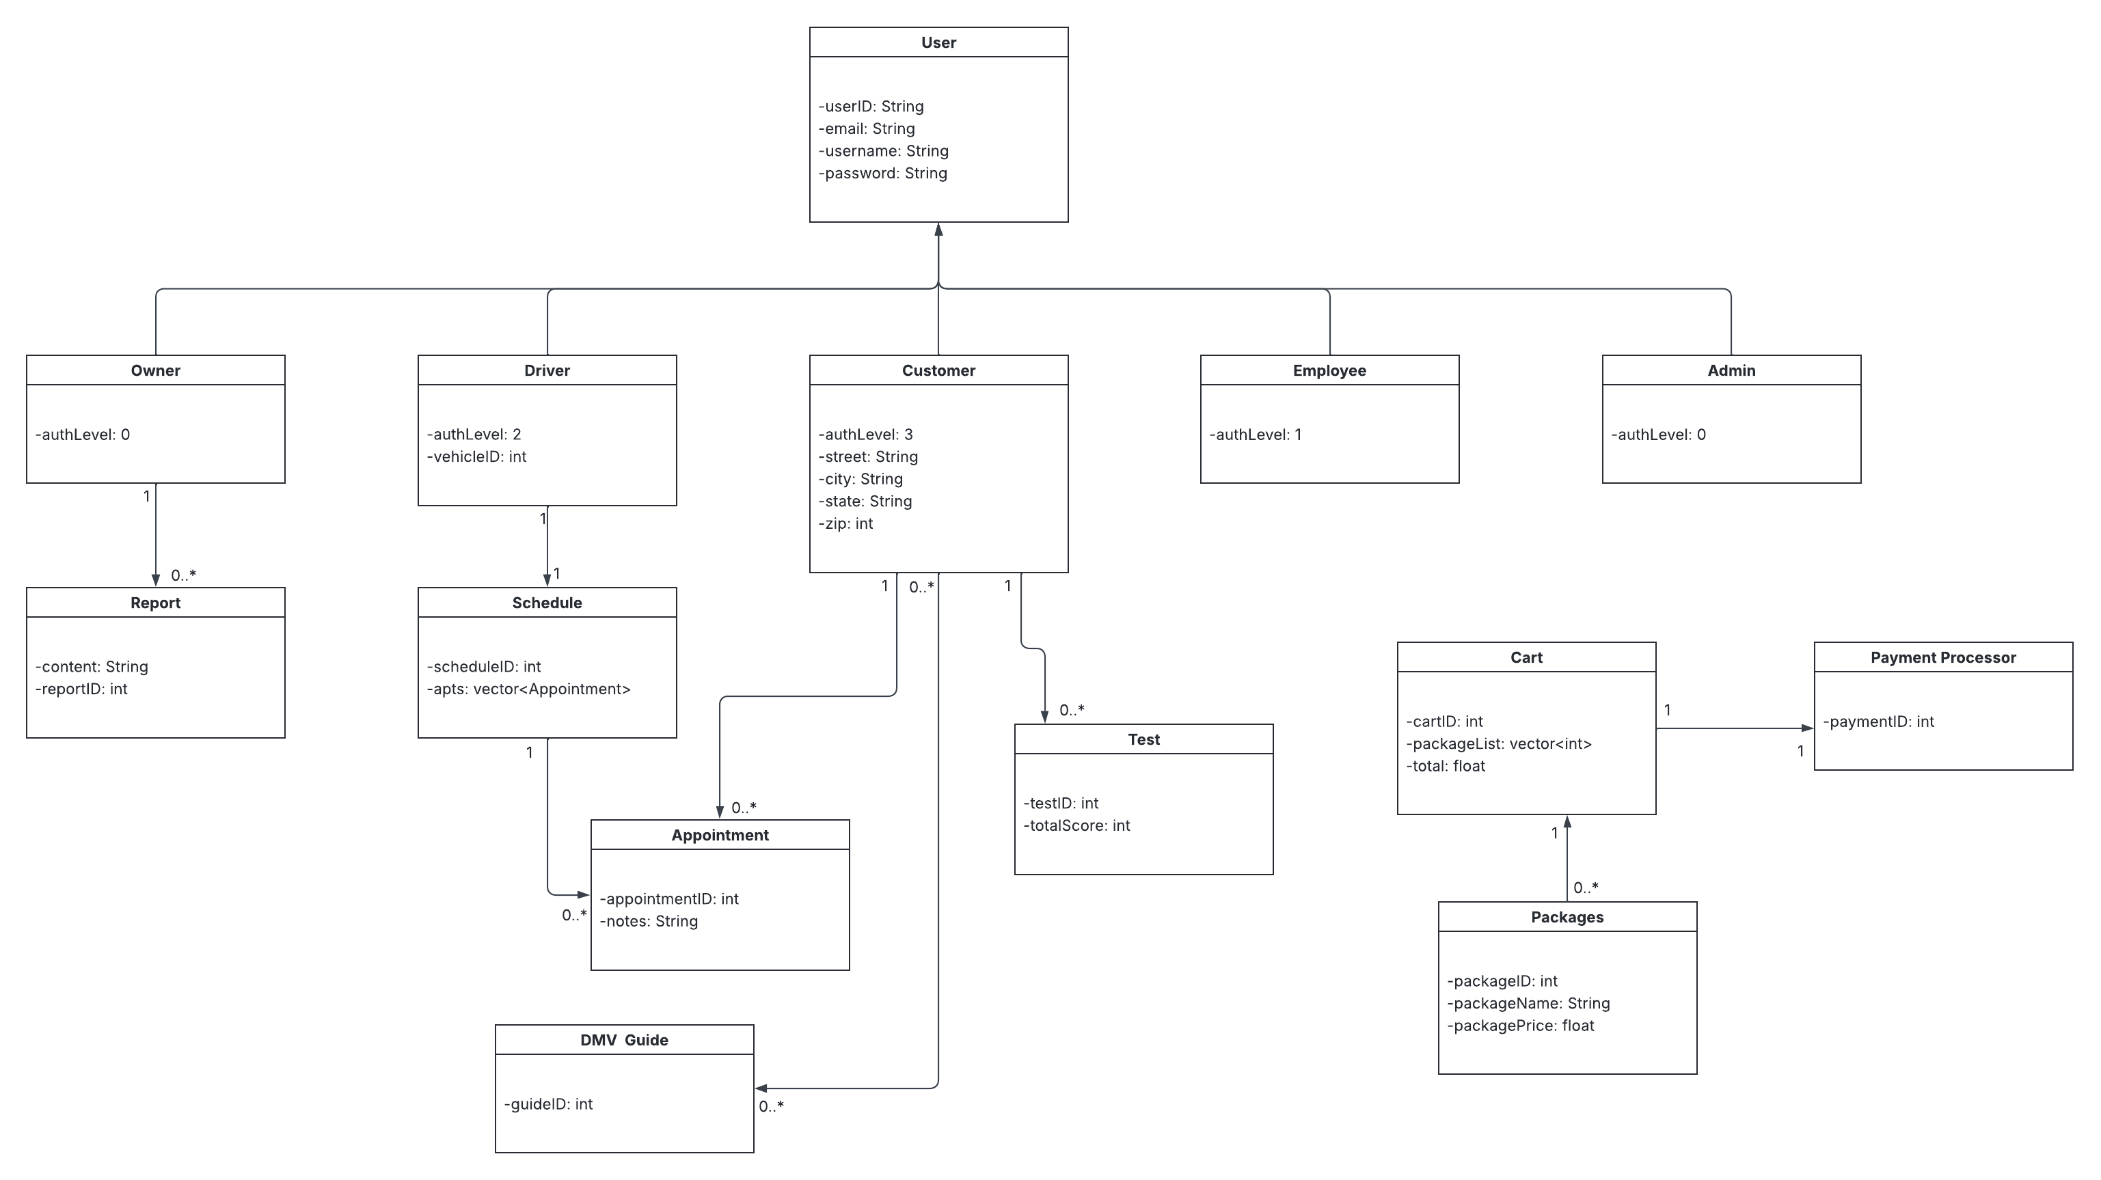

Technical Requirements
[Based on the diagrams you have created, describe the technical requirements of your system. These requirements should address the required hardware, software, tools, and infrastructure necessary for your system design.]

DriverPass is going to be a cloud-based web application available for desktop computers, laptops, tablets, and mobile devices. The system needs to have a safe database in order to keep all the customer accounts, training packs, appointments, test results, payments, driver notes, and scheduling information. Role-based access control will allow to make sure that customers, employees, the owner, and the IT officer only have access to the functions and data that concern their roles. User authentication, password encryption, and a secure connection will be necessary for customer and business data protection. Moreover, DriverPass will need an integration with some third-party online payment processor in order to accept payments in a secure way. The system should automatically send email confirmations about user registration, reservation, and payment. For the purpose of scheduling and providing training services, it is necessary to keep track of instructors' availability, vehicles used, lessons reservations, practice tests, and progress of drivers. Additionally, the system needs to prevent any scheduling conflicts and keep the schedule up-to-date. Finally, backups, system monitoring, cloud hosting, and DMV updates are necessary for DriverPass.

